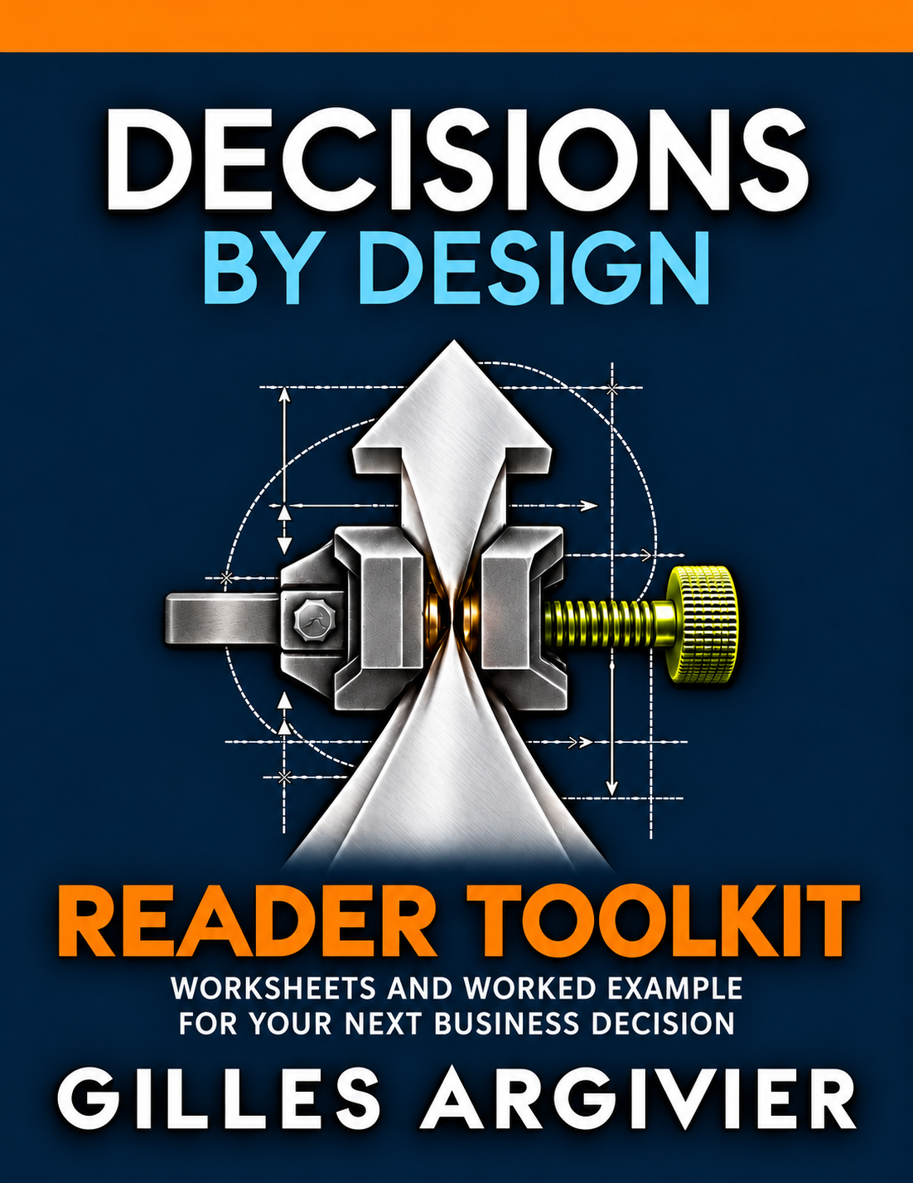

Start with one decision
How to use this toolkit
A promising result can justify another test before it justifies a larger commitment. Use this toolkit to make that distinction visible in one live business decision.
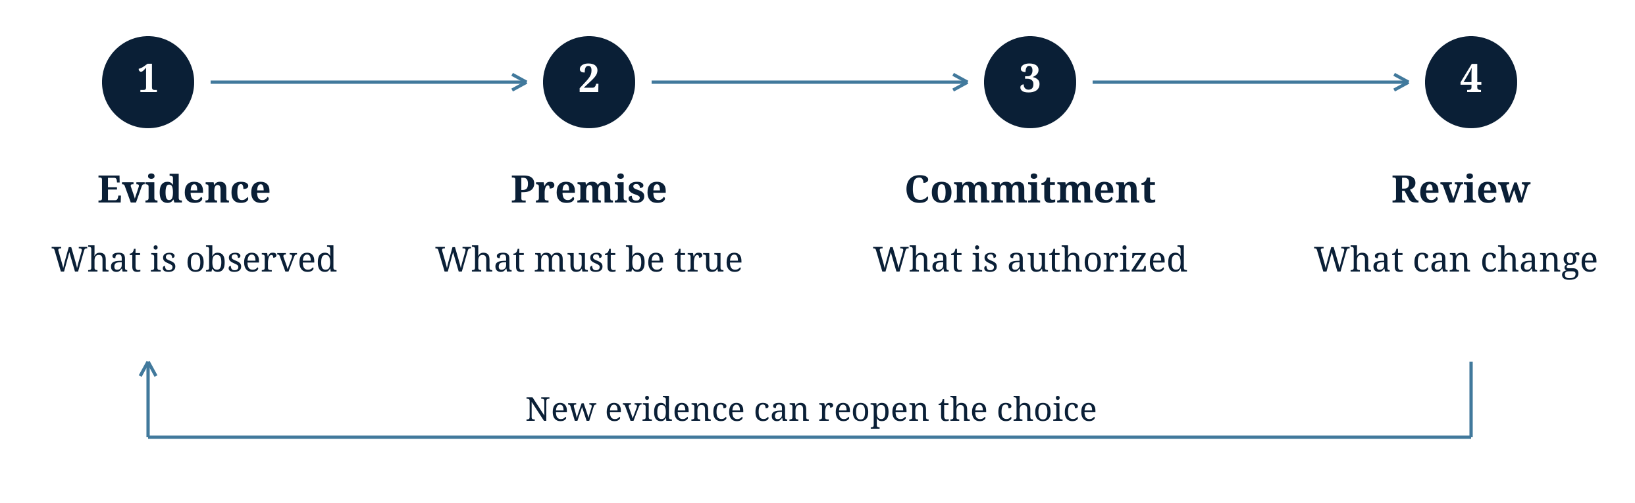

Choose a decision you can still influence
For example, expanding a pilot, renewing a supplier or increasing a budget. Name the choice, rather than the general problem.
The decision I want to review

Use the toolkit in this order
1 Scan the seven conditions on page 2.
2 Complete the decision record on pages 3 and 4.
3 Use the example on pages 5 and 6 where it helps.
4 Agree the action and review route on page 7.
You should leave with a clearer choice, the uncertainty being accepted and a named person able to act when new evidence arrives.
Adapted from Chapter 11 of Decisions by Design. These are proposed working aids, not a validated assessment. Match the depth of review to the stakes and reversibility of the choice.
© 2026 Gilles Argivier

Seven conditions to examine
Find what could change the preferred option
Use these questions to examine the setting around your decision. Focus on the conditions that could affect the choice; no score is required.

Signals
What evidence is missing, delayed or defined in a misleading way?

Assumptions
What must be true, and what observation would weaken that belief?

Authority
Who can approve, challenge, pause or revise the commitment?

Incentives
Could someone meet a local target while making the wider result worse?

Constraints
Which dependency or capacity limit actually restricts the choice?

Operating Rhythm
Will evidence arrive while a different action is still possible?

Feedback and Adaptation
When results change, who can change the next decision?

Which conditions need attention first
Name one or two and the evidence needed to examine them.

The seven conditions examine the organizational setting. The six fields on the next pages organize one choice. Their relationships can overlap.

Decision record
Part 1 Define the choice and its basis
Decision ___________________________ Owner ______________________
Date ______________________________ Version _____________________
Type into this Word version or write on the printed pages. Attach evidence or calculations when needed. Keep the same name and version on page 4.

1 Decision and alternatives
What action is proposed, at what scope and under which conditions? Compare credible alternatives, including continuation where feasible. Name the actual approver.

2 Objectives and trade offs
What counts as success, for whom and by when? Separate mandatory requirements from preferences. State the measures and trade-offs being accepted.

3 Evidence and premises
What do observations support, and what remains an estimate or projection? Give sources and limits. Name the premise that could change the choice. Is further testing worth its cost and delay?

Decision record
Part 2 Establish action and reconsideration
Decision ___________________________ Owner ______________________
Date ______________________________ Version _____________________
A proposed permission or resource is not a confirmed one. Mark unknowns and identify who must resolve them.

4 Dependencies and rights
What must be available, and who controls it? Include capacity limits and affected people. State the accepted downside, who bears it and who can authorize it. Mark unknown rights or motives.

5 Proposed change and comparison
Why is this action preferable to the alternatives, at what cost? Keep a competing explanation in view. Name the implementation owner, committed resources, first action and deadline.

6 Review and response
What evidence or event reopens the choice? Who brings it forward, and who can act? State what would weaken the diagnosis. After review, record the decision, next action and any costly obligation.

Worked example
Part 1 Test the complete offer
Hypothetical example. All figures, roles and thresholds are invented to show how to use the record. This is not an Ecoliss operating account or a commercial forecast.

1 Decision and alternatives
A manufacturer proposes a recyclable-casing appliance at €55 beside a conventional €50 option. The choices are a national rollout, a limited pilot, redesign or deferral. The general manager can approve the pilot; wider launch needs a separate decision.

2 Objectives and trade offs
Test demand for the price and performance together. Product and safety requirements must be met before stores receive stock. The team accepts a later launch if the demand evidence remains weak.
Illustrative review thresholds are two units sold per store per week over four complete trading weeks, with no stockouts, and at least €8 contribution per unit after variable costs.

3 Evidence and premises
Surveys suggest interest in sustainability. They do not establish willingness to buy this offer. The premise to test is that enough shoppers will accept its price and performance together.
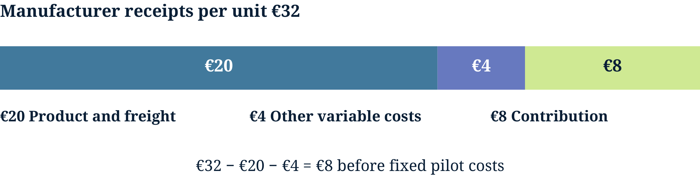
Illustrative unit model. Other variable costs include allowances, expected returns and servicing. Actual pilot results must replace these estimates. Fixed pilot costs are additional.
Store observations can explain objections. Comparing different appliances tests complete offers; it cannot isolate the effect of recyclable material alone.

Worked example
Part 2 Preserve the next choice
Continuation of the hypothetical example. The permissions and controls below are stipulated for illustration.

4 Dependencies and rights
The retailer confirms eight stores, shelf placement, price display and weekly reporting. Product and compliance leads confirm requirements; operations confirms supply and servicing. The pilot waits until these conditions are met.
The general manager accepts a €12,000 cap on cash commitments, including stock and support. Finance checks the cap. The product lead can pause for safety; the general manager can revise or stop the pilot. The manufacturer bears the unsold-stock exposure.

5 Proposed change and comparison
The commercial director runs four trading weeks with 160 units across eight stores, after finance checks the commitment and the retailer agrees a start date. A pilot limits exposure but costs time and money. Rollout commits more cash; redesign delays testing; deferral postpones learning.

6 Review and response
Review weekly and after four complete weeks. Pause for a safety failure; seek a new decision before exceeding the cap. Missing data, stockouts or changed placement prevent a simple threshold comparison. Retain placement and unfamiliarity as possible explanations for weak sales.
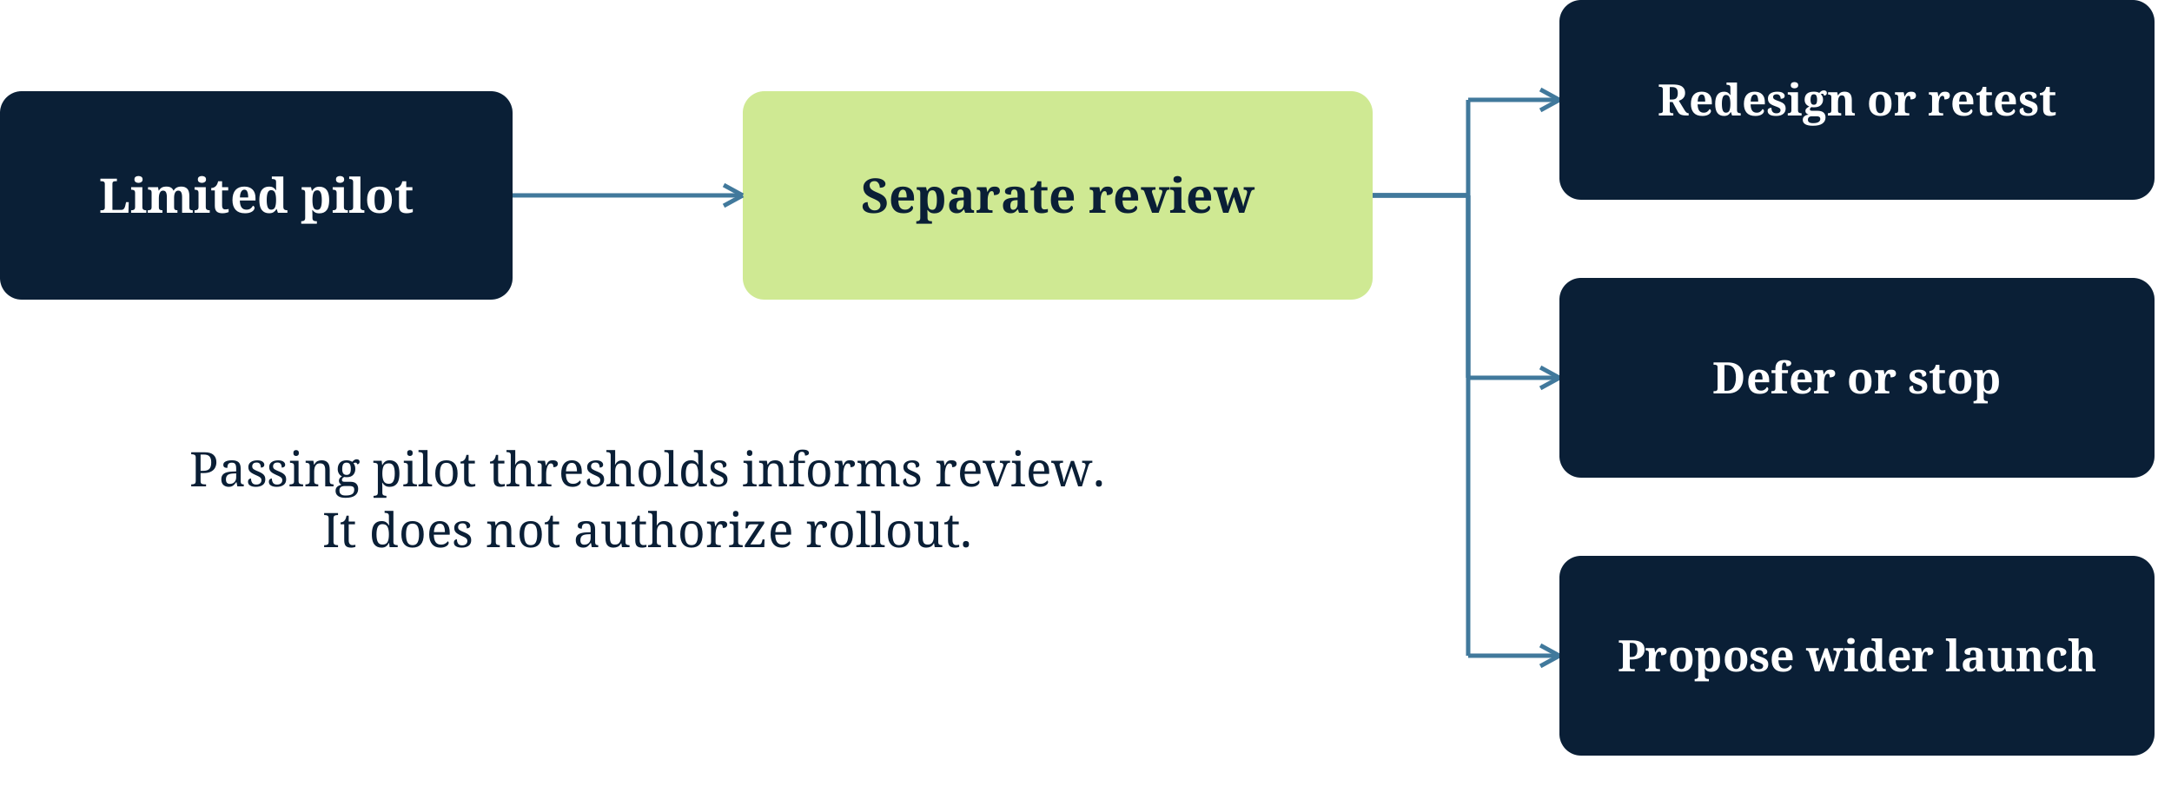
At review, examine sales, contribution, returns, shopper objections and execution differences. The general manager chooses the next action. Wider demand and capacity remain open questions; unit contribution does not establish total pilot profitability.

Team review guide
Finish with a decision someone can act on
Bring the owner, a person able to challenge the key premise and the people controlling important dependencies. Include the approver or establish a clear route to them.

Ask before committing more
• Which alternative best meets the objectives under current conditions?
• What evidence could change our choice before it becomes costly to reverse?
• Could local targets, hidden expert support or a dependency explain the apparent result?
• Who bears the accepted downside, and who can authorize or reduce it?

Record the outcome
Decision and reason What continues, changes or waits, and why?

Owner and action Who does what, with which resources and by when?

Reconsideration Which evidence or event reaches which approver, and when?

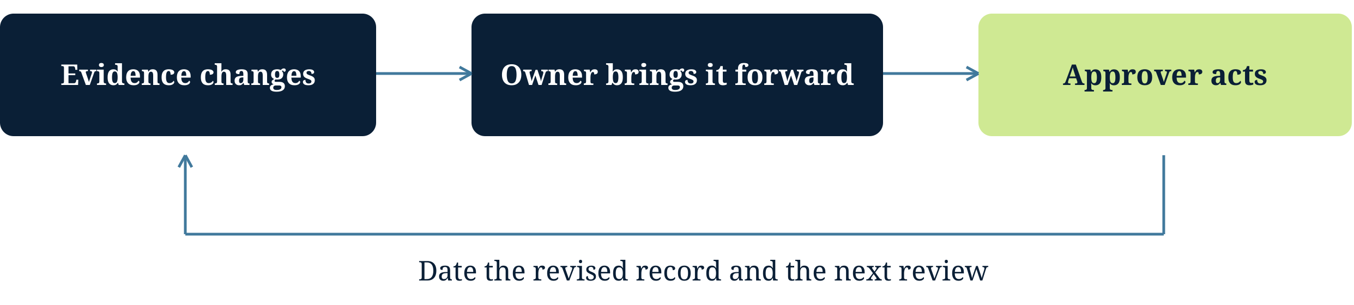
Keep the earlier record. Date the revision and state what changed in the reasoning or decision system. A useful review may support continuing the current course.
To discuss a decision affecting your business, visit gillesargivier.com.

